Laura Ingalls Wilder’s Childhood
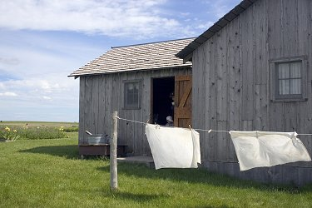
Laura Ingalls was born in 1867 in a little log cabin in the big woods of Wisconsin where she enjoyed playing in the densely packed forests of her home. Her earliest memories were of traveling in her family’s covered wagon together with all of their belongings and heading to Kansas with her Ma and Pa, her big sister Mary, her little sister Carrie and her faithful bulldog, Jack.

When they finally arrived in Kansas, the Ingalls decided to build a new “little house” on the grassy frontier prairie. Log by log, Ma, Pa, Mary and Laura built their own home, till at last Laura had enough time to go exploring the surrounding grassland with Mary. Laura’s family lived a happy life on the farm, but soon discovered that their farm was located on the land of a native tribe named the Osage, and so, once more, they had to move away.
This time, Laura and her family, headed back to their little house in the big woods of Wisconsin, the place where it had all started. Although the Ingalls loved their old home, the woods soon grew more and more in human population, until it was so filled with people there wasn’t enough game to go around. And so again, with heavy hearts, the Ingalls packed their belongings into the covered wagon, and left their old home for the last time.

The family’s next home was a one room sod house next to Plum Creek, near the little town of Walnut Grove, Minnesota. The girls went to school in Walnut Grove, and Laura learned to love reading and writing. But the sod “house” wouldn’t do, and Pa soon built a wonderful home, this time made with sawn lumber from Walnut Grove’s lumber mill, and in addition, they all enjoyed the fruits of a field of golden wheat.

Then one day grasshoppers came, big hordes of them that ate up every piece of greenery in sight, and the Ingalls’s entire wheat crop was ruined.

That year, Pa had to go work in the nearby city of Burr Oak to find work. The months without Pa were long, and even when he came back, Pa was restless on the farm, and so the entire family moved to Burr Oak, Kansas, where a new baby was born, named Grace.

Work was hard at the Burr Oak Hotel, and every member of the family was working non-stop to make ends meet. They soon traveled back to Walnut Grove, when Pa heard of a new job in Dakota Territory and was gone. Months later, Ma, Laura’s sister Mary, now blind, Carrie and Grace joined Pa by train.

Although they missed the prairie and its endless plains, the Ingalls never moved again. Laura spent the rest of her childhood in the promising town of De Smet, South Dakota, which had sprung up overnight a year after Laura’s family’s arrival.

